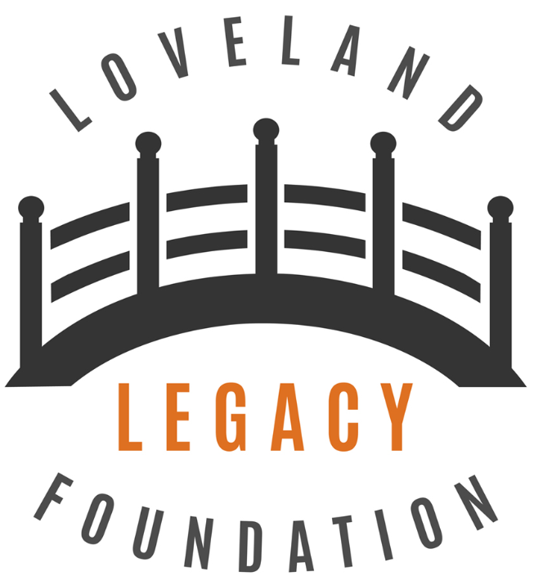

Grant Application

Applications must be for initiatives that support the Loveland Legacy Foundation mission and vision. Submit your completed application to legacy@lovelandlegacyfoundation.org .
The Loveland Legacy Foundation’s mission is to improve the community through an action-based culture, engaging with organizations sharing a common vision, connecting needs to solutions.

Name of Organization/Cause:
Contact Name:
Contact Email:
Contact Phone:
Organization Website (if available):
Date of Submission:
Describe Organization’s Mission or Focus:
Describe How Organization Compliments Loveland Legacy Foundation’s Mission:

Describe the Nature of the Request:
Amount Being Requested:
Organization’s Annual Operating Budget:
Describe How Funds Would Be Spent to Support the Organization’s Mission or Focus:
Additional Comments:

